 | English AC V9 — Year 1
Unit 2: Examining, creating and sharing informative texts
Assessment task — Information reports☼
The K–6 Curriculum Planning Model (K–6CPM) for Australian Curriculum V9 English models a tailored approach to curriculum organisation, drawing from level descriptions, text types and integration of strands to support synchronous systematic curriculum implementation in multilevel contexts across Kindergarten to Year 6. This flexible model streamlines content and assessments through aligned contexts, allowing for adaptation of yearly contexts to sustain engagement and relevance.
Unit 2 focuses on ‘reporting information’ as a common theme. Unit contexts across successive years may explore a range of informative texts, for example:
- procedures, descriptions, explanations of a process and personal responses
- a selection of classic and contemporary informative texts
- literature of wide-ranging Australian and world authors, including that of First Nations Australians and texts from and about Asia.
The K–6CPM includes supplementary resources to support implementation in a range of schools including small schools and larger schools with complex and/or multilevel contexts.
This assessment task is aligned to the aspects of the achievement standard being assessed. Individual school contexts will inform decisions about how the task is to be implemented and how students will engage with the task.
The assessment task gathers evidence of student learning for these aspects of the Year 1 English achievement standard:
Reading and viewing
- Read, view and comprehend texts, monitoring meaning and making connections between the depiction of characters, settings and events, and to personal experiences.
- Identify the text structures of familiar narrative and informative texts, and their language features and visual features.
Writing and creating
- Create short written and/or multimodal texts including recounts of stories with events and characters.
- Report information and experiences, and express opinions.
- Ideas in their texts may be informative or imaginative and include a small number of details from learnt topics, topics of interest or texts.
- Write simple sentences with sentence boundary punctuation and capital letters for proper nouns.
- Use topic-specific vocabulary.
Speaking and listening
- Share ideas and retell or adapt familiar stories, recount or report on events or experiences, and express opinions using a small number of details from learnt topics, topics of interest or texts.
- Sequence ideas and use language features including topic-specific vocabulary and features of voice.
The following materials can be used when implementing Unit 2: Examining, creating and sharing informative texts in the K–6CPM English Year level plan example.
See the English Unit 2 Curriculum and assessment alignment planner (CAAP) to guide unit planning when developing a teaching and learning sequence and implementing the assessment in the unit.

Assessment conventions and resources
Purpose: To read, view and comprehend an informative text and identify text structures and language and visual features of imaginative and informative texts. To create a written multimodal information report. To report information in a presentation to an audience.
Technique: Observed demonstration (Part A and Part C); extended response (Part B)
Conditions
- Administer the task individually with students.
- Provide the task to students in a way that is age-appropriate.
- Length of student responses should be considered in the context of the assessment and appropriate to the year level.
- May be completed over multiple lessons.
Resources
- Example decodable text: Sheet — Informative text: Dogs (provided)
- A pet dog (pg. 1) aligns to:
- AC V9 sub-strand: Phonic and word knowledge including word structure, CV, CVC and high-frequency words, for example: ‘the’
- Literacy Hub: Phonics progression phases 1–3 (Prep).
- Fun facts (pg. 2) aligns to:
- AC V9 sub-strand: Phonic and word knowledge including word structure, CCVCC, CCCVC, CCCVCC, one- and two-syllable words and high-frequency words, for example: ‘there’, ‘their’
- Literacy Hub: Phonics progression phases 1–11 (Year 1).
- Students are expected to read the entire text, noting that the text includes some challenging words for them to demonstrate decoding at a higher level.
- Words in the text could be adapted to align to the phonics scope and sequence used by individual schools.
- Background knowledge text, Sheet — Background knowledge text: Dogs (provided)
- Familiar authentic narrative text on a similar topic as the informative text, for example: Sterling, best dog ever by Aidan Cassie.
Implementation advice
- Adapt this assessment task to suit the diverse needs of the students, school and local context.
- When adapting the assessment, maintain alignment to the targeted achievement standard aspects and aligned curriculum elements and consider ways to make the assessment meaningful and accessible for students.
- Answer spaces have not been included to provide flexibility in how and where students will respond.
- Each part of the summative assessment may be conducted as a series of smaller tasks contributing to a collection of work to be used to gather evidence of student learning against the marking guide.
- The assessment offers tasks across varying language modes – listening, speaking, reading, viewing and writing. Teachers can adapt tasks to allow students to demonstrate the full extent of what they know, understand and can do in multiple ways. This approach ensures accessibility for varied learning needs and supports students’ unique ways of seeing, hearing and/or processing language.

Part A: Reading and viewing
Before administering the task, students engage with texts about the topic to build relevant background knowledge. Background knowledge texts can be read to students. For example: Sheet — Background knowledge text: Dogs (provided).
Select a decodable informative text that aligns with explicitly taught phonics scope and sequence program and students’ phonic development, for example: Sheet — Informative text: Dogs (provided). Students respond to questions in a teacher interview.
Instructions
- Ask students to:
- independently read aloud the decodable informative text
- monitor their own reading and, if needed, use learnt self-correction strategies
- answer questions about the text.
- Provide students with a familiar narrative text, for example: Sterling, best dog ever by Aidan Cassie. Students are not expected to independently decode this text.
- Guide students to answer questions about structure, language and visual features and identify similarities and differences between the two text types.
- Teachers may use Sheet — Teacher interview.
Note: The provided informative decodable text can be used as part of a monitoring strategy to inform judgments about students’ ability to read texts using developing phonic knowledge, phrasing and fluency, and monitoring meaning. Alternatively, a text could be selected that aligns to the school’s explicitly taught scope and sequence program and students’ phonic development.
Part B: Writing and creating
Students create a short written multimodal information report including a small number of details on a topic from learning, texts and/or experiences. They write using topic-specific vocabulary. They choose images for their text that contribute to meaning.
Instructions
- Ask students to select a topic to report information and/or experiences.
- Guide students to plan and talk about information about their topic and how they will present their report.
- Guide students to write facts about their topic. Prompt them to use:
- emerging knowledge of report structure
- simple sentences with some sentence boundary punctuation
- noun groups
- a small range of adjectives, adverbs and verbs to add details
- capital letters for the beginning of sentences and proper nouns (when required)
- topic-specific vocabulary
- words, illustrations and/or diagrams to contribute to meaning.
- Guide students to re-read and edit their sentences to make sure they make sense, add or delete words to improve meaning and check spelling.
- Guide students to read their sentences to an adult and refine their work.
- Students may use the Sheet — Writing (optional) to organise their ideas.

Part C: Speaking and listening
Students report information on an event or experience to an audience. When preparing their short spoken presentation, students can use their written information report as a helpful guide. Remind them that they may use the same information and topic-specific vocabulary, and should include an opening and concluding statement. They should enhance the presentation with gestures and features of voice such as volume and pace.
Instructions
- Guide students to plan their presentation and sequence their ideas.
- Provide opportunities for students to gather supporting images such as photos, illustrations, diagrams and maps for their presentation. Students may also like to use costumes or props (optional).
- Provide time for students to share their presentation with a peer or adult to practise staying on topic.
- Prompt students to:
- introduce themselves (for example: ‘Good morning. Today I am presenting my report on …’)
- report their information with some details
- sequence their ideas
- include topic-specific vocabulary
- use presentation skills including features of voice, for example: appropriate gesture, volume and pace for a small audience
- conclude the presentation (for example: ‘Thank you for listening to my presentation …’).
Teachers may use Sheet — Presentation: Teacher recording sheet (optional).
☼ Source: Australian Curriculum www.australiancurriculum.edu.au, CC BY 4.0. © Australian Curriculum, Assessment and Reporting Authority (ACARA) 2010 to present, unless otherwise indicated. This material was downloaded from the Australian Curriculum website (www.australiancurriculum.edu.au) (Website) (accessed 01/04/25) and was modified. The material is licensed under CC BY 4.0 (https://creativecommons.org/licenses/by/4.0). Version updates are tracked in the ‘Curriculum version history’ section on the ‘About the Australian Curriculum’ page (http://australiancurriculum.edu.au/about-the-australian-curriculum/) of the Australian Curriculum website. ACARA does not endorse any product that uses the Australian Curriculum or make any representations as to the quality of such products. Any product that uses material published on this website should not be taken to be affiliated with ACARA or have the sponsorship or approval of ACARA. It is up to each person to make their own assessment of the product, taking into account matters including, but not limited to, the version number and the degree to which the materials align with the content descriptions and achievement standards (where relevant). Where there is a claim of alignment, it is important to check that the materials align with the content descriptions and achievement standards (endorsed by all education Ministers), not the elaborations (examples provided by ACARA).
 | English AC V9 — Year 1
Unit 2: Examining, creating and sharing informative texts
Assessment task — Information reports

Name |  | Class
Teacher |  | Date
Part A: Reading and viewing
You are going to read aloud an informative text. You will then answer questions about the informative text and a storybook in an interview with your teacher.
Part B: Writing and creating
You are going to write a multimodal information report for an audience.
- What is your topic?
- Think about words you have learnt about this topic.
- Plan and talk about some information to report on.
- Write sentences about your topic. Remember to:
write information with details
write in simple sentences
start your sentence with a capital letter and finish it with a full stop, and use capital letters for proper nouns
use nouns and describing words
use topic words.
- Add a drawing, picture or a diagram with labelling to match your sentences.
- Review and edit your work:
read your sentences to check they make sense and that your spelling is correct
think of any words or images you could add to improve meaning.
Part C: Speaking and listening
You are going to report information to an audience.
- Plan how you will present your information.
- Practise reporting your information to a partner. Share ideas about what you did well and what you can improve on.
- Present your information to the audience.
Remember to:
introduce yourself and your topic
report your information in order with words that add details
include topic words you have learnt
use the presentation skills you have practised
include your images, costumes or props (optional)
end the presentation.
 | Marking guide — Year 1 Unit 2
AC V9 English | Name:
Assessment task — Information reports☼
Purpose: To read, view and comprehend an informative text and identify text structures and language and visual features of imaginative and informative texts. To create a written multimodal information report. To report information in a presentation to an audience.
 | Speaking and listening | Reading and viewing | Writing and creating
 | Share ideas and retell or adapt familiar stories, recount or report on events or experiences, and express opinions using a small number of details from learnt topics, topics of interest or texts.  Sequence ideas and use language features including topic-specific vocabulary and features of voice. | Read, view and comprehend texts, monitoring meaning and making connections between the depiction of characters, settings and events, and to personal experiences.  Identify the text structures of familiar narrative and informative texts, and their language features and visual features. | Create short written and/or multimodal texts including recounts of stories with events and characters.  Report information and experiences, and express opinions.  Ideas in their texts may be informative or imaginative and include a small number of details from learnt topics, topics of interest or texts.  Write simple sentences with sentence boundary punctuation and capital letters for proper nouns.  Use topic-specific vocabulary.
Applying | Recounts or reports on a topic from events or experiences including an introduction and conclusion and using a small number of details from learnt topics, topics of interest or texts.  Sequences ideas and uses language features including topic-specific and precise vocabulary, and experiments with features of voice and gesture. | Reads, views and comprehends an informative text, monitoring meaning, making connections to personal experiences and summarising with key details and drawing inferences.  Compares the organisation, language and visual features of informative and imaginative texts and links to purpose. | Creates a short written and/or multimodal informative text to report information on a familiar topic using topic-specific vocabulary, relevant details from learnt topics or texts, and images chosen to suit purpose and contribute to meaning.  Writes grammatically correct simple sentences with noun groups to report an idea or event and build description, applying sentence boundary punctuation and capital letters for proper nouns.
Connecting | Recounts or reports on a topic from events or experiences including an introduction and using a small number of details from learnt topics, topics of interest or texts.  Sequences ideas and uses language features including topic-specific vocabulary, and experiments with volume and gesture. | Reads, views and comprehends an informative text, monitoring meaning, making connections to personal experiences, identifying information with details and drawing inferences.  Identifies similarities and differences between narrative and informative texts. | Creates a short written and/or multimodal informative text to report information on a familiar topic, using topic-specific vocabulary, informative ideas and details from learnt topics, topics of interest or texts, and combining visuals with text to suit the purpose.  Writes grammatically correct simple sentences to report an idea or event, with sentence boundary punctuation and capital letters for proper nouns.
Working with | Recounts or reports on a topic from events or experiences using a small number of details from learnt topics, topics of interest or texts.  Sequences ideas and uses language features including topic-specific vocabulary and features of voice. | Reads, views and comprehends an informative text, monitoring meaning and making connections to personal experiences.  Identifies the text structures of familiar narrative and informative texts, and their language features and visual features. | Creates a short written and/or multimodal informative text to report information and experiences about a topic.  Ideas in texts may be informative and include a small number of details from learnt topics, topics of interest or texts.  Writes simple sentences with sentence boundary punctuation and capital letters for proper nouns.  Uses topic-specific vocabulary.
Exploring | Recounts or reports on a topic from events or experiences using including an opening or concluding statement.  Organises ideas and uses language features including topic-specific vocabulary and/or features of voice. | Reads words, phrases or sentences in a simple informative text, and views supporting images, making a relevant statement about the text.  Identifies a familiar imaginative and/or informative text type and makes a statement about a text structure, language feature or visual feature. | Creates a short written and/or multimodal text about a topic using images and/or words in sentences or sentence fragments.
Beginning | Shares ideas or thoughts about a topic, event or experience using language features such as rehearsed phrases. | Reads words in a simple informative text, and views supporting images, making a simple statement about the text or topic.  Identifies a feature of a familiar imaginative or informative text. | Creates a short written and/or multimodal text on a familiar topic using words and/or images.
Feedback:
 | Sheet

Informative text — Dogs
Dogs
A pet dog
The dog can sit.
It can run and dig.
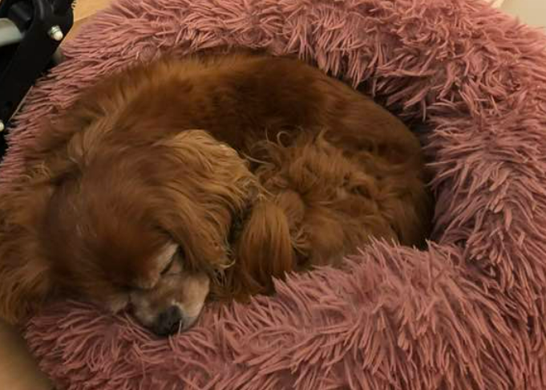
The dog can nap and yap.
dog bed
dog

Fun facts
- There are lots of dog breeds.
- A pup is a baby dog. The mum picks it up by the scruff of the neck.
- Dogs dream in their sleep.
- Dogs are smart. They bark and howl. This is how they speak to us.
- All dogs have a strong sense of sight and smell.
- Some dogs can help us with work and keep us safe.
- Some dogs can be trained to tell when we are sick.
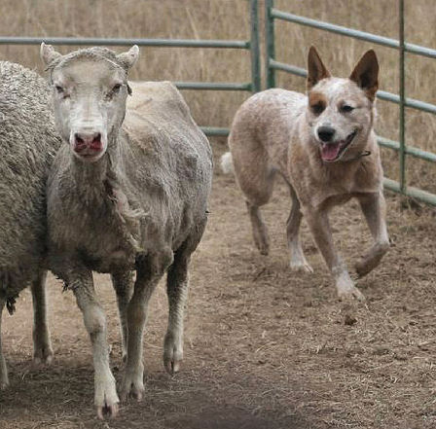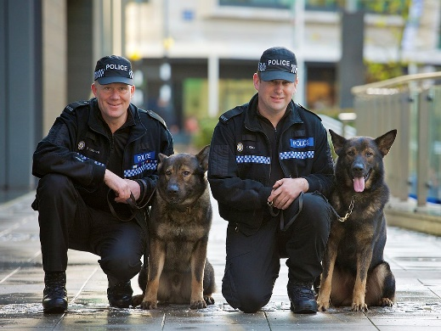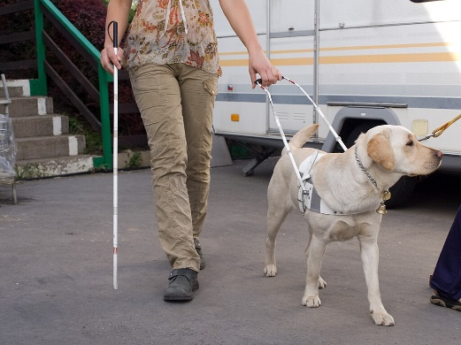
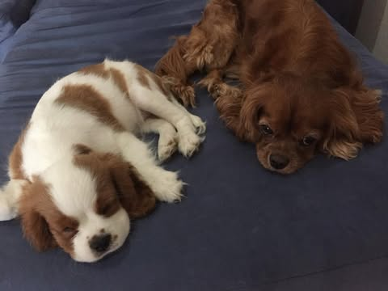
scruff
mum
eyes
nose

 | Sheet

Background knowledge text: Dogs
Dogs
Dogs are mammals. This means they have a skeleton, a body covered with fur and they feed their babies milk. Their babies are called puppies. Dogs belong to a group of mammals called ‘canines’, which also includes foxes, wolves and dingoes.
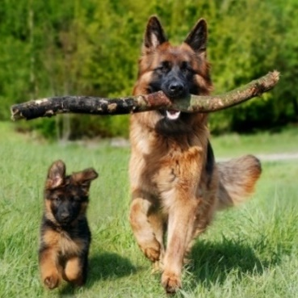 | 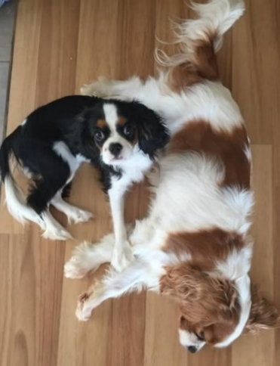 | 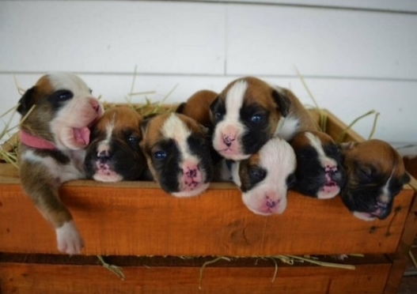
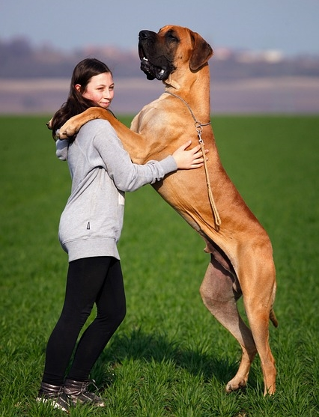
Dog breeds
There are many different breeds of dogs. Dogs can be many shapes, sizes, and colours. Some dogs are small, like chihuahuas, and some are very large, like Great Danes.

Working dogs
Dogs have excellent senses of sight, smell, and hearing. This makes them good helpers for lots of jobs. Some dogs work as police dogs, military dogs, guide dogs for blind people, or rescue dogs.
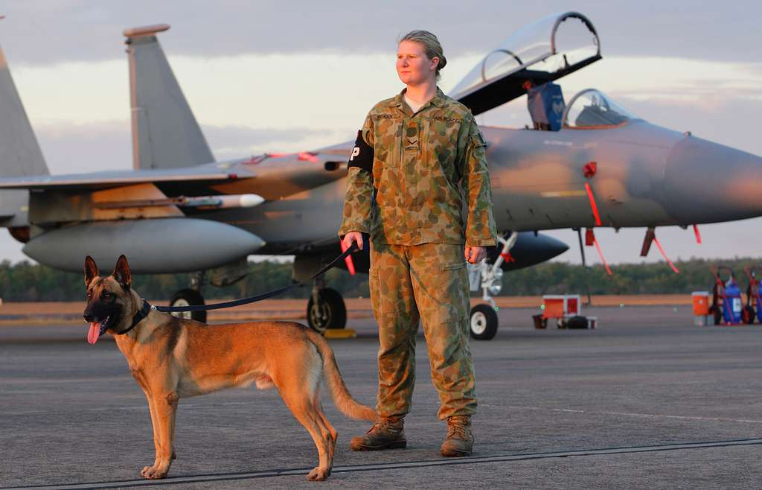 | 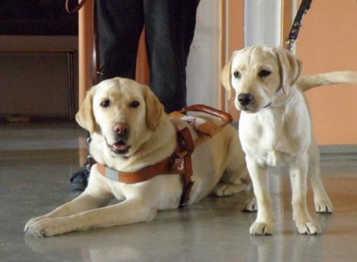 | 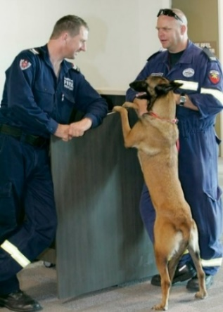
Australian Airforce dog | Guide dogs | Rescue dog and officers
Domesticated dogs
Some dogs are wild dogs and live outside but most dogs are domesticated. For thousands of years, dogs have lived and worked with people. Dogs are excellent companions, which is why they are sometimes described as ‘our best friend’. | 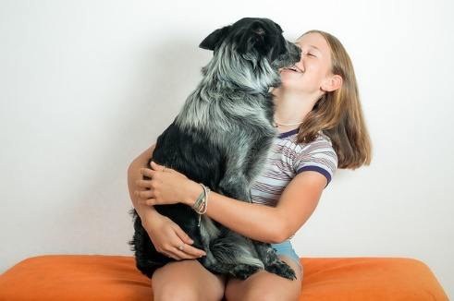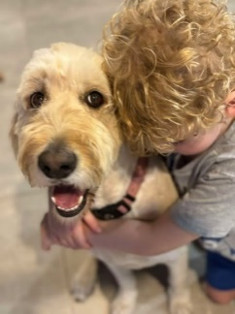
Keeping dogs healthy
Dogs need to eat a diet with lots of meat. They also can eat fruits and vegetables for extra vitamins. Not all meat, fruits, and vegetables are safe for dogs though, so owners need to be careful about their diet. Dogs should eat special pet food or other safe food. Dogs also need regular exercise like going on long walks, chasing after balls or playing with their owners.
Attributions
 | Courtesy of K Bryant. Used with permission.
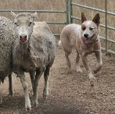 | Mdk572 2006, Australian cattle dog herding, https://commons.wikimedia.org/wiki/File:Australian_Cattle_Dog_Herding.jpg, CC BY-SA 3.0, https://creativecommons.org/licenses/by/3.0/deed.en
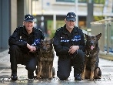 | West Midlands Police 2012, West Midlands Police - Dog handlers receive awards, https://commons.wikimedia.org/wiki/File:Day_341_-_West_Midlands_Police_-_Dog_handlers_receive_awards_%288251729393%29.jpg, CC BY-SA 2.0, https://creativecommons.org/licenses/by-sa/2.0/deed.en
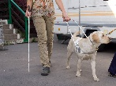 | Honza Groh 2010, SVVP Klikatá, vedení nevidomého, https://commons.wikimedia.org/wiki/File:SVVP_Klikat%C3%A1,_veden%C3%AD_nevidom%C3%A9ho.jpg, CC BY-SA 3.0, https://creativecommons.org/licenses/by-sa/3.0/deed.en
 | Courtesy of K Bryant. Used with permission.
 | Courtesy Pixabay.
 | Courtesy of K Bryant. Used with permission.
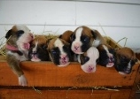 | Courtesy of A Jones. Used with permission.
 | Courtesy Pixabay.
 | Courtesy Pixabay.
 | Defense Visual Information Distribution Service 2011, Australian military working dog teams provide security at RAAF Base Darwin during Talisman Sabre 2011, Public Domain https://www.dvidshub.net/image/431082/australian-military-working-dog-teams-provide-security-raaf-base-darwin-during-talisman-sabre-2011
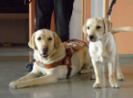 | Smerikal 2011, Guide dog looks at next generation, https://www.flickr.com/photos/smerikal/5555788581, CC BY-SA 2.0, https://creativecommons.org/licenses/by-sa/2.0/
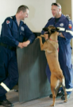 | Australian Department of Defence photostream 2011, Search and rescue dog and handler heading off to Japan, https://www.flickr.com/photos/aus_defence_force/5527462587/in/photostream/, CC BY-NC-ND 2.0, https://creativecommons.org/licenses/by-nc-nd/2.0/
 | Courtesy Pixabay.
 | Courtesy of V. Alexander. Used with permission.

 | Sheet

Teacher interview
Instructions
Review an informative text and a narrative on a similar topic. Ask students questions about the texts. Responses may be dictated to a scribe to reduce the literacy demands of the assessment. Prompts may also be provided to support students to complete the assessment, for example: ‘Tell me more’, ‘What else?’
Reading and viewing
Guiding questions | Student responses/Observations
Identifying purpose, audience, text structures and language and visual features of an informative text
What is the topic of the text?
Tell me what this text is about. Give some details from the text.
Why can dogs be trained?
How do dogs help us?
What features make this an informative text?
Why would people read an informative text?
Making a connection
What does this text remind you of?
Why does it remind you of this?
Comparing texts
What features make this a story?
Why would people read a story?
What things are the same about an informative text and a story?
Think about the organisation and language and visual features.
What things are different between an informative text and a story?

 | Sheet

Presentation
Teacher recording sheet (optional) Year 1 Unit 2
AC V9 English | Name: |  | Date:
Assessment task — Information reports

Skills |  | Comment
Use a simple introduction (for example: ‘Good morning, my report is on …’)
Include topic-specific vocabulary
Report information by sequencing ideas and using a small number of details
Experiment with features of voice and gesture
Conclude the presentation (for example: ‘Thank you for listening to my report on …’)
Note: Students may demonstrate the presentation skills outlined in this checklist in a structured semi-formal presentation. Teachers may adapt this list to suit individual students and use the completed checklist to make a judgment about the skills demonstrated in this task and required further learning.

 | Sheet

Writing (optional)

Write information about your topic. |  |  | Include a drawing or diagram about your topic. Use topic words to label your picture.

